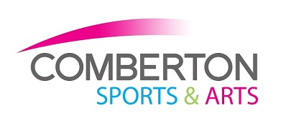 | USER GUIDANCE  FOR EVERYONES SAFETY

COMBERTONSA.ORG | 01223 264 444 | COMBERTON SPORTS AND ARTS
Whilst the nation comes out of the pandemic Comberton Sports & Arts would like to ensure that we operate in a way that keeps everyone safe. We hope you can join us and do your bit to preserve a safe exercise environment. Whilst we have lifted some restrictions, we hope the measures outlined below will make a difference and they doesn’t hinder your experience and enjoyment. |  | 

What we are keeping in place to keep you safe:
- All Comberton Sports & Arts staff self-test twice per week for COVID 19.
- Hand sanitiser and cleaning stations are available to use at key areas throughout the Centre. `
- Provide disinfectant wipes and spray within each fitness facility for our customers to use.
- The one-way system from the reception area to gain access to all other indoor venues.
- Disinfectant cleaning of fitness equipment/contact points 3 times per day and request that customers disinfect equipment and contact points used.
- Ventilation ‘natural air flow’ for each indoor facility: We will open all the doors and windows prior your arrival.
- Highly recommend all customers wear face masks at reception and whilst walking through the corridors.
- A QR Code can be found at reception which we highly recommend you use.
- We are to retain the booking system for the Weights Room (3 people per hour).
- Please make sure you arrive on time for your booking and not any earlier. We still want to avoid crowd gathering so that we can maintain social distancing.
- Our changing rooms are now open. To be disinfected every 3 times per day.
- The CSA Café is to reopen with social distancing measures and retaining contactless payments only.
We would like to thank you all for your continued custom and adherence to these new precautions.
Enjoy your exercise and please stay safe!

